Perfomance Comparison of different batch mode clients
by – Mrigesh Madaan and Sanchit Khanna

NOTE1 : All the clients use a file called “thetext”. Data from this file is tranffered to server in case of (a) to (d) and is tranffered to client in case of (e) anb (f). A program called “createFile.c” has been included which can be used to generate this file to be of any desired size.

NOTE2 : The times have been measured using a 1GB file. 10GB file was taking a lot of time to transfer in some cases, which is why we chose to tranfer only 1GB file.

NOTE3: Part(e) and Part(f) of the questions require the use of the file server2.c

Part (a) : Blocking IO with Select
The psuedocode for this part is mentioned below. The psuedocode is pretty much self-explanatory.

main (){
socket();
connect();
startDataTranferClock();
while(1){
setFDs();
select(sock+1, &rfds, &wfds, NULL, NULL);
if( isReadable(sock) ){
startResponseTimeClock();
read(sock);
stopResponseTimeClock();
}
if( isWritable(sock) ){ write(stdout);}
clearFDs();
}
stopDataTransferClock();
}

Part (b) : Non-blocking IO with Select
This part uses non blocking IO for sending and receiving using select. The main crux behind achieving this part is buffer management. Rest all is similar to what was done in the blocking IO part. This part involves two buffers (of 1KB) : toBuffer and fromBuffer. There are two pointers required to manage each of the buffers.
ToBuffer is used to keep the data that is to be sent to the server. It has two pointers : “toiptr” and “tooptr”. Data that is present after the “tooptr” represents the data that is yet to be written to the socjet and sent to the server. Data after the “toiptr” is actually empty space meaning that data can be read into this buffer after this pointer. Whenever data is sent, tooptr is incremented by the number of bytes sent. Both the pointers are adjusted once the buffer has been completely sent to the server.
FromBuffer is used to keep data that has come from the server. This data is then written to stdout. It is also managed by two pointers : friptr and froptr. Data after froptr is yet to be written to stdout and data after friptr is empty space and more data can be read into this space from the server.
The psuedocode for this part is mentioned below. The time measuring calls have been ommitted to provide clarity

main (){
socket();
connect();
setNonBlocking(sock,file,stdout);
while(1){
setFDs();
select(sock+1, &rfds, &wfds, NULL, NULL);
if(isReadable(file)){
read(file, toBuffer, sizeof(toBuffer));
manageBufferPointers();
}
if( isWritable(sock) ){
write(sock,toBuffer,sizeof(toBuffer));
manageBufferPointers();
}
if( isReadable(sock) ){
read(sock, fromBuffer, sizeof(fromBuffer));
manageBufferPointers();
}
if(isWritable(stdout)){
write(stdout, fromBuffer, sizeof(fromBuffer));
manageBufferPointers();
}

clearFDs();
}
}

Part (c) : Two Processes
In this part, the client process forks a new child process. The parent and the child, both share the same socket connection. The child process is used to send the request to the server. It reads the text from a file and writes it to socket. The parent process is used to receive the replies from the server. It reads from the socket and wrote to stdout. Both the parent and child use blocking IO.

Part (d) : Two Threads
In this part, the main thread spawns a new thread. The new thread is used to send data to the server while the main thread is used to receive data from the server. This part also makes use of blocking IO.

Required time measurements (averaged over three runs for 1GB file): Please note that the programs are taking a higher time to run becuase output is being printed on the terminal. If out is not printed, time taken by the program is significantly less(in the range of 15-20secs).

 | Time for data transfer (seconds) | Time per request (seconds) | Throughput  (Bytes/sec)
Blocking IO | 338.843 | 0.000339 | 2951214.957
Non-Blocking IO | 201.982 | 0.000201 | 4950924.368
Two Processes | 324.548 | 0.000324 | 3081797.098
Two Threads | 321.037 | 0.000321 | 3114902.529

Part (e) : Non Blocking IO with Non Blocking Connect (requires server2.c)
In this part, the programs tries to connect to a server using a non-blocking connect and as soon as connection is established, a new Thread is spawned to receive data from the server. On the server side as soon as a new connection is established, the server starts sending data by reading from a file.
The following psuedocode illustrates the above.

establishMultipleConnections(){
nLeftToConnect = maxConnections;
while( nLeftToConnect > 0 ){
sock = socket();
if( nonBlockingConnect(sock) == true){
arg=sock;
pthread_create(&tid, NULL, func, arg);
// “func” is a function that is to receive data from the server using // non- blocking IO
// This non-blocking IO is the same as that in part (b)
}
nLeftToConnect--;
}
}

Let us say that 4 parallel connections have been opened by the client to the server. The server is a fork based server and hence creates a child process to handle every new client. For the file being read on the server, every new child shares the same file descriptor of that file. This can be shown as the following figure:

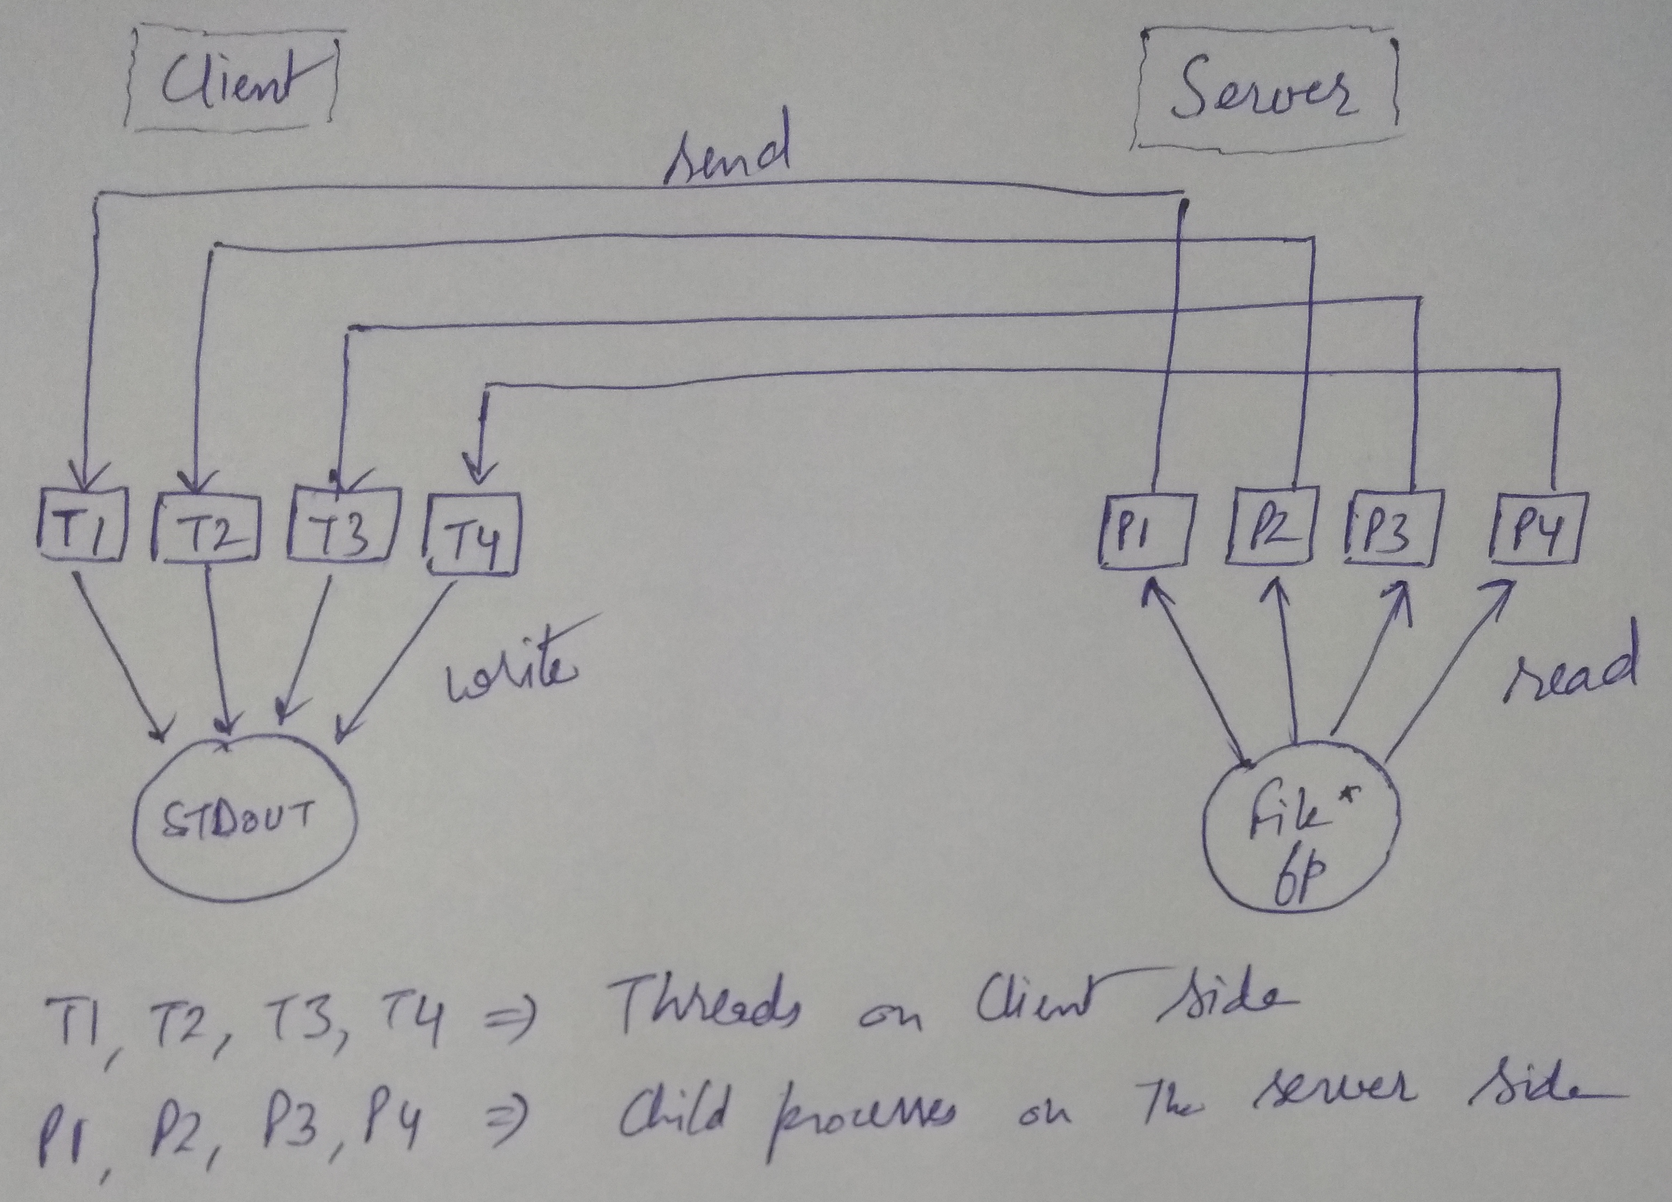
On the server side, since all the processes are reading from the the “same” file descriptor, duplicate data is not sent to the client. However, the data that is received at the client side may be out of order. For example, consider the case where processs P1 reads from the file descriptor and sends to the client thread T1 and then process P2 reads from the file descriptor and sends to the client thread T2. However, let us say that the data from P2 arrives first and this will be written to stdout and then data from P1 arrives and is written to stdout. As we can see, due to some delay, the order of the data arriving on the client was changed.
This can be mitigated by many ways(by making use of lseek, for example). However, since the goal of the assignment was to measure times for “transer of data”, this synchronization of data arriving has not been implemented in the program.

Part (f) : Blocking IO with Threads (requires server2.c)
This part is essentially the same as the previous part. The difference is that we are blocking IO in this part instead of using non-blocking IO. The psuedocode for this part is as follows.

establishMultipleConnections(){
nLeftToConnect = maxConnections;
while( nLeftToConnect > 0 ){
sock = socket();
if( connect(sock) == true){ // changed here
arg=sock;
pthread_create(&tid, NULL, func, arg); // changed here
// “func” is a function that is to receive data from the server
// “func” in this case employs blocking IO
}
nLeftToConnect--;
}
}

Required time measurements ( for transfer of 1GB file):

Observed trends for Non-blocking IO with Non-blocking Connect:
There is a general trend of decreasing data transfer time per second with the increasing number of connections. The difference between consecutive number of connections becomes smaller as the number of connections become higher.
Another observation is that, for higher number of connections, if we try to compare a client with parallel connections as “n” and a client with parallel connections as “n+1” (where “n” is even ), We will observer that the client with “n” connections performs better (for example n=4,6,10,12). This might be possible because these programs were run on a dual core processor. Since for “n+1” parallel connections, an even split of processes is not possible, 1 core is left with higher amount of processes which leads to a larger data tranfer time.
We believe that the effects of “number of parallel connections” will be more pronounced if we run this over a production server rather than running this on local host.

Observed trends for blocking IO with Threads:
Again, the effect of changing the number of parallel connections are not clearly visible (with one outlier at x=13). However, It can certainly be established that blocking IO threads are taking more time to complete the data transfer than the non-blocking threads for any number of parallel connections.
Again, we believe that a production server is reqired to analyse the performance under real-life scenarios.

